Конкурс на звання кращого знавця англійської мови

Жанр Рецепти національних українських страв

Назва роботи Ukrainian meals

для здобувачів освіти закладів вищої чи фахової передвищої освіти

П.І.Б. Змунчило Данило Сергійович
Заклад вищої чи фахової передвищої освіти (навчально-виховний підрозділ)
Фаховий коледж «Освіта»___________________________________________
Форма навчання (денна, заочна) денна_______________________________
Курс 1 курс________________________________________________________
Група КЛ- 22-2_____________________________________________________
Спеціальність Інженерія програмного забезпечення

Контактні телефони (домашні, мобільні) +380634888494
е-mail d.zmunchilo@gmail,com

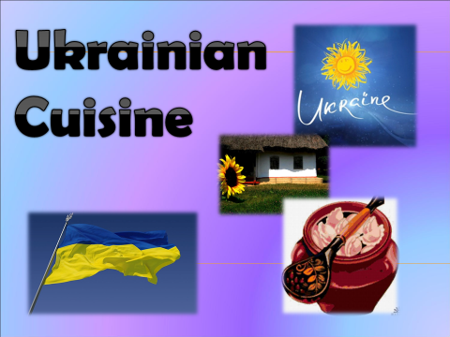
Ukraine is a country of rich history about probably the most willpowered people to exist, protecting their independancy and language throughout centuries. So it shouldn’t come as a big surprise that Ukrainians have a very diverse and tasty cuisine. People in Ukraine like to eat good and tasty food cooked of fresh products. Fast food is not very popular in Ukraine as Ukrainian women prefer to cook at home. And many of them are real masters at cooking.
Since old time Ukrainian national cooking has been famous for great variety of tasty and healthy dishes. Ukrainian women always collected recipes of cooking different dishes. This tradition is kept nowadays as well.
The most popular dish in Ukraine which every Ukrainian lady can cook is borshch. It has up to 20 components. There is a proverb that says: “Each hostess has her borshch” as there is a lot of variants to cook it. Soups are very popular in Ukraine. And you can find a lot of them in Ukrainian cuisine. The most popular of them are yushka, sherba (fish soup), chicken broth, noodle soup, pea soup, mushroom soup and milk soup. All of them are very tasty. Next up we have bograch, another soup-like lunch. It is has meat, various vegetables and a bell pepper. While originated in Hungary, it spreaded to the western side of Ukraine - Transcarpathia, eventually becoming one of the, if not the most poular traditional meals in that region.
Last soup we are going to talk about is the cold kvass soup, which in Ukrainian formal speaking is “okroshka”, a rather interesting meal. It contains basic soup fillings like herbs, meat and vegetables, but every single ingredient it contains is minced to little pieces, creating a “salad” of sorts. Then, cold kvass is poured into the mix, giving it a unique sweet-sour taste. The most interesting thing about it is that people eat it cold! The diversity of the Ukrainian kitchen is fascinating!
Moving on from soups we’ll speak about meat dishes.Ukrainians cook meat in different ways. You will be able to try cutlets, boiled meat, meat dumplings, fried and roasted meat here. People usually have meat as the second course or as a main course. As a garnish or as a side dish they usually have fried, boiled or mashed potatoes, vegetables cooked in different ways or salads. There are a lot of dishes cooked from flour. In Ukraine you can try varenyks, pancakes, halushkas and different kinds of pies.So, vareniks. It is a boiled dough that has something inside, preferably mashed potatoes, meat or lettuce. Sometimes people eat it as a desert, because vareniks can also be filled up with sweet ingredients, like cherries. This has been accepted as a very quick-to-cook food, because nowadays all that is required is to go to a shop, buy frozen vareniks and boil them at home. A lazier aproach than making the dough and filling by yourself, but with sour cream still tastes amazing, a perfect dinner after a long day when you are too tired to cook something yourself.
Finally, we are going to talk about a special snack – salo. Salo is another enormous giant in Ukrainian food stereotypes, it might even be the most widespread one. Salo is a specifically cooked animal fat, most often from a pig. There is no sertain set in stone way to cook salo, some might had their own secret recipe. Everyone eats salo differently, some sprinkle it with salt or pepper, some eat it with bread and garlic. It was used on almost every single dinner table, serving as a tasty snack for many centuries. Although, salo isn’t used as much as it was used before, it is still always a welcome dinner delight.
Among traditional drinks you will find kvas, uzvar, stewed fruit, juice, sour
milk. Sure, tea, coffee and cocoa are also very popular here nowadays.
Traditionally Ukrainian alcoholic drinks are not very strong. They are good
wines, honey drinks and beer.Stronger drinks, like horilka,traditionally had herbs
and were used in small doses to warm the body but not to make the person drunk.
In conclusion – Ukrainian сuisine evolved for many centuries, and still to this day never manages to dissapoint. It has food for any time of the day and mood, also the accessebility of the ingredients comes in handy, as you can cook it right at home without huge money waste and cooking difficulties. There are many more examples left, we just looked at the most popular. Although most of the food comes from a very long time ago, it stays practical and loved by everyone untill this very day.
Ukrainian cuisine has variety of receipes. And it is worth trying!

