Конкурс на звання кращого знавця англійської мови

Жанр Історія спеціальності

Назва роботи My future profession

для здобувачів освіти закладів вищої чи фахової передвищої освіти

П.І.Б. Беспаль – Доронченко Анжеліна Денисівна
Заклад вищої чи фахової передвищої освіти (навчально-виховний підрозділ)
Фаховий коледж «Освіта»___________________________________________
Форма навчання (денна, заочна) денна_______________________________
Курс 1 курс________________________________________________________
Група КЛ- 22-1_____________________________________________________
Спеціальність Журналістика_________________________________________

Контактні телефони (домашні, мобільні) +380730733702
е-mail angelinabespal@gmail,com

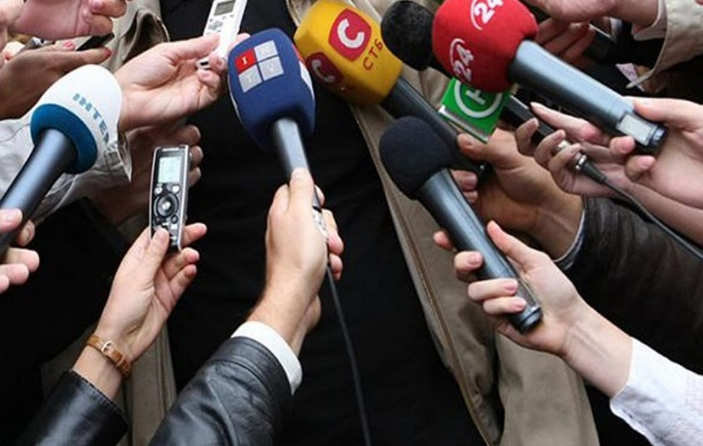
Finishing school is the beginning of the independent life for millions of school leavers. Many roads are open before them: technical schools, institutes and universities. There are many professions in the modern world and it is very difficult to choose the one you like. Some people follow the advice of their parents, others can’t decide even after leaving school.
As for me I made my choice 2 years ago. Since childhood I dreamed of becoming an actress. Went to author's art courses, played in the school theater, danced. But nevertheless I decided to become a journalist. For some reason my heart fell on this. My choice of this occupation didn’t come as a sudden flash. During all school years literature was my favourite subject. I have read a lot of books by Ukrainian and English. I understand that reading books helps people in self – education and in solving different life problems.
Why do I want to become a journalist? Because journalism still remains one of the most popular and demanding professions. A journalist is a person who writers news reports for newspapers, magazines, television or radio. Journalists have a lot of responsibilities. Their job is to collect, report and analyze news. Their main task is to inform people on present, past and future events. This information should be independent, reliable and accurate as it can influence the life of the society. A person who wants to become a journalist must have higher education, know psychology and foreign languages. It is not an easy task to be able to write compositions on different topics. Knowledge of grammar is of great importance to as modern media should educate people. To become a well-known journalist a person must be sociable, creative, communicative, honest, reliable, brave, clever and bright. All these traits will help you to write the truth, face danger and problems.
The profession of a journalist has a lot of advantages. Real professionals have fame and money. They have a rare chance to see the world at the cost of their boss. Journalists always know more than others. Any news first gets into the hands of journalists. Access is open almost anywhere. With a journalist's card, you can enter everywhere. Will always be surrounded by interesting and creative people, also with celebrities. And, certainly, prestige. A good journalist does not remain in the shadows. And what a great power it is to be able to form people’s views and opinions.
Nowadays journalism is especially important because of the war. Ukrainian and foreign journalists travel to hot spots to show the whole world what is happening in Ukraine. They risk their lives to inform people, to illuminate the plot.
Due to the lack of contact with their relatives, many Ukrainians cannot find out what is happening in their hometown. And this information is provided by journalists who travel around different cities and show the streets.
Internet media is very useful because people can quickly find the information they need. Currently, they mostly publish about air raids, shelling, missile hits, the latest news in the political universe. And also they continue to write about other areas of life.
However, this job is really dangerous. Hundreds of journalists are killed every year. Then they often have to work in unbearable conditions such as cold or mud. At the same time they do not have enough time for their families and friends. In many countries people do not have the freedom of speech.
Providing security to journalists is the main problem, because it is almost impossible to fully ensure one's security by choosing this profession. The danger of a journalist is caused by the fact that often with their speeches, coverage and statements, they affect the interests of criminals, dishonest politicians, corrupt officials, etc.
At least 19 civilian journalists were killed during the full-scale invasion of Ukraine. During shelling; some went missing, and later were found killed. And some journalists even went to fight and died on the battlefield.
Because of the war I was forced to leave for Italy. Here I was offered to go to school or enter college. Athough I always wanted to study abroad,but now I refused. Because during the war, my attitude towards both Ukraine and Europe has changed.
In fact, everything in Europe is not as glorious as we are told, Italy is no exception. Life here is not like what I used to see in the movies. Personally, their rhythm of life does not suit me, because it is too boring. Italians are very slow, relaxed, in no hurry and do not overexert themselves. I don't like education in Italy in general. Comparing education in Italy and Ukraine, I can definitely say that it is preferable in Ukraine, at least in Kyiv and Lviv.
At last I decided that I really want to study in Kyiv. That’s why, this year I entered Proffessional collage ”Osvita” of Higher Education Institution Open International UNIVERSITY of Human Development “UKRAINE”. I think that this profession is combined with the knowledge I’ll get at the collage and it would be quite enough to succeed in my work. It is a difficult, dangerous, heroic, but very necessary profession. I am sure my dream will come true sooner or later. It’s a pity, but now I have to stay abroad and study remotely. But I believe that Ukraine will win and we will return home.
UKRAINE WILL WIN!!!

